MIKE O’RYZA AND THE VEXING VIEW
After visiting Parramatta, my associate Perry Enkema and I journeyed north to the hinterlands of Queensland, to work some cases with an associate, Cal Modulin. We followed his directions to a cabin on a hilltop, and pulled into the driveway. Perry unloaded our diagnostic gear while I reconnoitered the site. I wondered how Cal got us such a great place to work from without any mention of money, but the sound of wheels crunching on the gravel driveway ended that speculation. I half-jogged back around the cabin, eagerly expecting to see Cal’s jeep pulling in, but instead it was a glossy new cobalt blue sedan.
A well-dressed gentleman, Japanese in appearance, slid out of the back seat as his crisply-uniformed driver held the door open. Perry ’s eyes bugged out as he rushed to stuff our ropes into a crate. I tugged the wrinkles out of my field coat and took off my hat as I walked up to meet the gent. “ Michael O’Ryza, at your service.” I greeted him with a soft bow. “We are here to investigate some of the local trees.”
“And I am Suzichi, owner of this property, and I am here to show you the first trees to investigate” the gent bowed quickly, his face betraying tension beneath its placid exterior. “My honored parents will be visiting later this year, and staying in this cabin. Our ancestral home is on the ocean, so they are most accustomed to the calming view of blue water. My motherdelights in wildlife, and the sight of birds large and small. My father is keenly aware of the auras around all plants, and expects our valuable trees to receive the highest standard of care.”
“Your parents sound most wise” I replied. “If there is anything we can do to prepare your property for their arrival, we would be most willing to help.”
“Our problem is vexing, and most perplexing. That is why Mr. Modulin recommended your involvement. Observe the view to the valley below.” I turned to look downward, and saw the problem straight away.
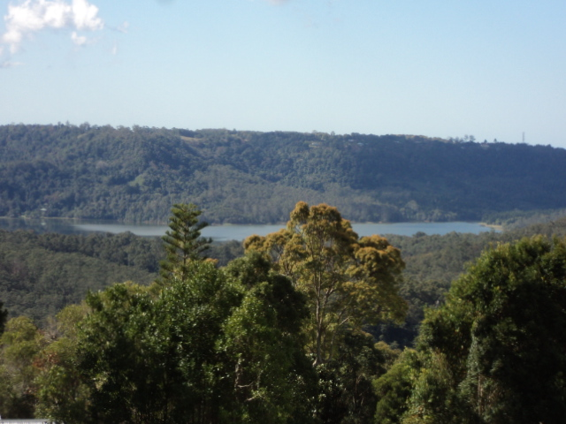

An Araucaria cunninghamii, the hoop pine, thrust its way into our view of the left side of a long lake. To its right, the round crown of a eucalypt obscured the azure surface. “A local tree man, Louie DaLopurre, advocates the historical practice of cutting the trees where a man can easily reach with a chainsaw. They regularly return to repeat the process, as nothing can restrain rampant regrowth in our rainforest region. My father might disapprove, and deny us family funds to purchase adjacent property. If you can find a way to meet my honored parents’ needs, the cabin is yours for the month.”
I nodded agreement. “Since that historical practice evolved, the technology of tree climbing, and tree care, has advanced. We will inspect the trees closely, and give our report to you tomorrow.” Suzichi bowed and slid back into the car. I thought I saw his chauffeur smirk over his shoulder as he drove off, but I paid him no mind. Perry grabbed the gear and we took off down the hill.
“Golly Mike, we’re stuck” he said, shaking his head. “We’re almost out of money, and look at these mature pines over there: they don’t round over into a decurrent form until they reach 20 meters (66 feet) or so. That one blocking the view is young—if it gets cut, it’ll sprout like crazy.”
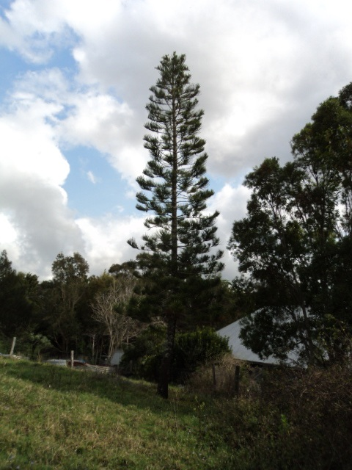
“So it might seem” I replied, studying the regular whorls of branches on the pagoda-like structure. “The distance between whorls decreases with height. I wonder…” We both turned our heads at the sound of a vehicle, and jumped out of the way as Cal’s jeep skidded to a stop.
“G’day, mates!” his voice rang as he hopped out and strode over, pumping Perry’s hand so hard the poor lad grinned with gritted teeth. I got Cal caught up on our assignment as we studied the eucalypt. “Mmm, that is a bit of a tough one” he mused. “Corymbia intermedia, the pink bloodwood, matures at 30 meters (100 feet), and this one’s barely 20. Looks like the left side got hammered in last year’s storms—that doesn’t help anything. The harder they’re lopped , the faster they sprout. Shall I ascend to assess additional clues?”
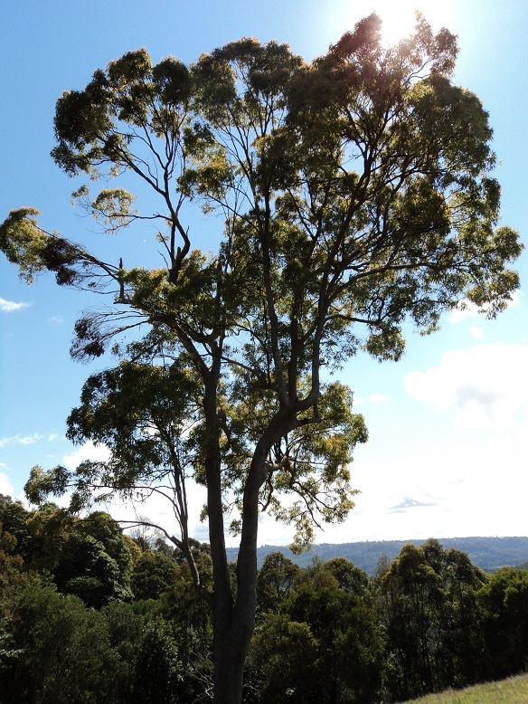
Perry and Cal chatted away as they set their ropes, clinked their carabiners, and ascended. I contemplated the condition of the crown. Multiple upright leaders close together indicated regrowth from old damage. They were at the same height low in the crown, so the older damage was by saw, not by storm. To the left, the broken branches still had leaves attached, a sign that damage was done the previous summer.
I zoomed in with my camera, and saw the strongest sprouts clustered at nodes, near old branch scars. I scanned upward toward Perry’s tie-in point, and saw a bright flash of color. Don’t make any sudden moves, Perry” I called up quietly. “You’ve got visitors—grab your camera.” Perry smoothly unsnapped his shirt pocket, wrapped the camera cord around his wrist, and got off several shots of the rainbow lorikeets.
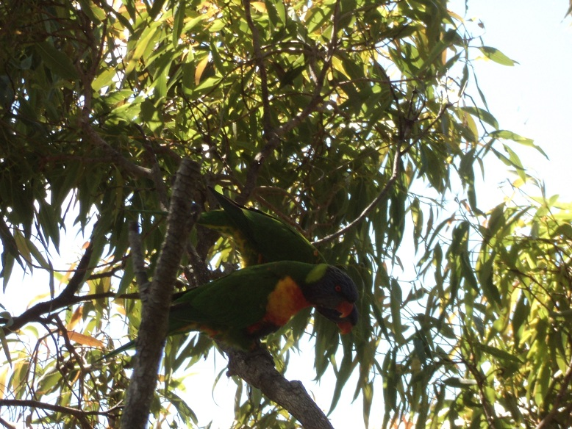
“Ah, they’re lovebirds, they are—typically travel in mated pairs.” Cal called down after the blue-headed duo flew off. “Their body language was like the tree’s: a positive response. One kept bobbing up and down-- probably the male, hoping to get lucky. August is spring, after all.” Both his bare hands wrapped around a branch. “Callus is strongly squeezing long-dead branches to shed them. That Wall 4 shows good resistance to decay. Sprouting response to exposure from that storm damage is at optimal locations for harvesting sunlight. Overall structure seems sound, but no lower laterals on these elongated upright limbs that emerge at the top. There is new growth all around the sunny parts of the crown.”
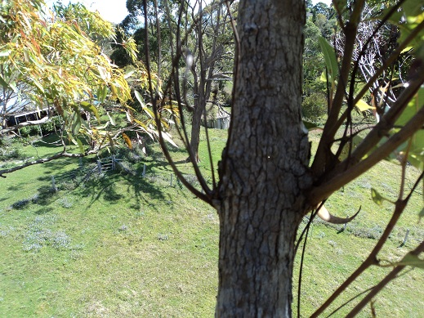 {Below the storm damage, sprouts emerge from buds at nodes, old branch wounds. The interior sprouts to the left withered, dried and died. The sprouts on the right used sunlight to build a buttress at the base of the burgeoning buds.}
“Good job, Cal.” I called up. “Perry, take some panoramic pictures of the property, then let’s wrap it up.” I circled the tree, hunting for hints to help hatch a plan that would earn us a free month’s rent. Visualizing the lorikeet bobbing up and down, I realized the bird knew the answer before I did.
TO BE CONTINUED
What did their feathered friend tell our team? If you were Mike, how would you handle this situation? Send in your answers to both info@plantamnesty.org and historictreecare@gmail.com . Answers received before May 1, 2013 will be entered in a drawing to win a free year’s membership with PlantAmnesty. One entry per person. All replies may be considered for publication by PlantAmnesty.

