Detective Dendro and the Cryptic Canker
The sound of the door slamming was followed by the thumping of boots. Codit entered the study and pointed to my headphones. ‘Hey Dendro, whatcha listening to? Is it true that Mozart’s best for reading comprehension?”
I set the book, pen and clipboard on the table, pulled off the headphones, and clamped them over Codit’s ears. His face crinkled with curiosity as he mouthed the words he was hearing-- “decline spirals have escape routes…”
“What’s better than Mozart for reading comprehension?” I laughed. “Try listening to a podcast on the topic, simultaneously. The next one in the Science of Arboriculture series is all about your favorite tree associates—fire ants!” Codit grimaced as he pulled off the headphones, so I hit Pause. “We can hear the rest on the way to our next case.”
As Codit drove I cought him up on the backstory. ‘I met her after presenting an outdoor Master Gardeners’ class some years ago. Her questions on the firmness of trunks were probing, and—well, she had a grand old oak tree that was hit by lightning, and she needed help. I eyeballed it from the ground and saw that the energy had jumped to the peak of the neighbopr’s roof. Its buttress was undamaged, and the tree eminently worth conserving. The contractors said they had no problems with the specifications on bark tracing and the lightning protection system—it does strike twice, as we have seen!—but I never did get back to see her—the tree, I mean…
The tree’ spoor response to the canker, and the uncertainty of its cause, indicated heavy steel cable. Now her neighbor, who shares part of the trunk, sent her a report stating the tree has severe defects, and must be removed. Our job is to assess the tree, and review and respond to the report.”
“Let me guess” Codit turned to me, sardonically. “I do the aerial assessment, and you wear the white hat and point.”
“Something like that” I laughed. “On the easier trees, I’ll let you report into your smartphone, and teach me a new friction hitch. The neighbor’s arborist—I have a good idea who-- listed seven “severe defects” that made tree failure ‘imminent: ‘ dieback in the upper crown, epicormic sprouting, limited root area, several open cavities, excessive pollen and acorn production, the aforementioned canker, and on a nearby limb is a large brown stain near the attachment. This indicates a systemic slime flux infection, for which there is no cure.’”
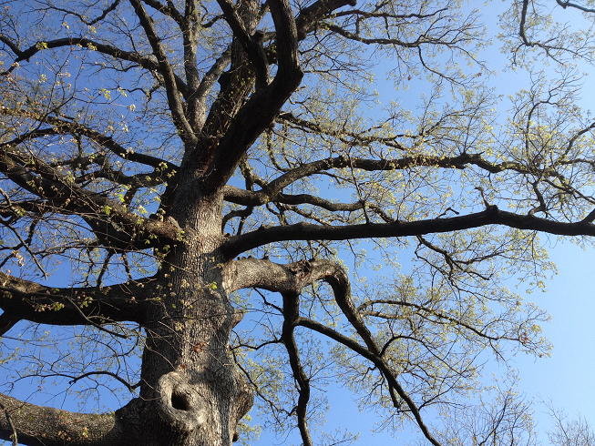
As I recall it, the crook is an odd formation, forcing the limb to dip downward toward the upscale home below. The canker is visible as a sunken area more on the side than the top of the limb, an odd location for a fungal infection. Their conclusion: the hazard to their house is severe, and removal is the only acceptable way to mitigate that risk.” I resumed the podcast for Codit, making time to mull over the list of seven conditions as I copied them from the report onto our company’s assessment form. I tapped the white space with my pen in frustration, first fast, then slow.
Codit paused the podcast. “Good stuff about managing decline, but then the speaker talked about pines being bad bets to keep on construction projects—what about Pinus taeda?”
“Loblollies are tough—on many sites” I agreed. “Generalizing is risky, but it’s part of inductive reasoning, which goes from the specific to the general. Diagnosing this oak canker will require deductive reasoningI added, “But enough speculation—pull in here, and we will see for ourselves.”
I hopped out and made sure the way was clear as Codit backed into the driveway and parked. He met me at the tailgate, looked up, and marveled as he grabbed his gear, “Wow, that tree is sure a beauty. The adaptive growth, or woundwood, is substantial on the upper margin, but not the lower—curious! The stain is darker than typical slime flux, but there are no fruiting bodies evident, which is consistent with slime flux. Ancient trees like this do not follow the growth patterns of trees that are merely mature.” I can’t wait to show you how it looks rom above.”

“Me neither” came the melodious voice behind us. She was tall, and waved to me with an air of amusement. “That report caught me by surprise. I had no idea my tree had so many problems—I’d like your view.”
“And you’ll get many views” Codit jumped in, buckling his saddle. “I’ll ascend your tree to the tip top, and inspect these areas of concern. From the ground we can see the crook and two cankers, with uneven adaptive growth, or woundwood. Substantial on the upper margin, but missing below—curious! The stain below it is darker than typical slime flux, but there are no fruiting bodies evident, which is consistent with slime flux. “
Thank you Codit. Up you go, now.” I grabbed my binoculars and led to a better view of the crown.
“Those dead branches in the very top concern me” she worried as she followed the jiggling green dot of my laser pointer. “There seem to be more this year. I thought that sprouts were good, but this report says they are signs the tree is desperate for energy.”
“Not all sprouts are the same— where they are located tells us why they grew--but we’ll talk about that later” I assured her. “The primary conditions of concern are the cankers, and Codit is taking a short walk on a crooked limb to inspect the old canker over your neighbor’s house. How’s it lookin’ up there, limbwalker?” I shouted.
There was a humming in my pocket. “Just fine” Codit answered over the speakerphone. “I’ll send a video of the resonance test.” He pulled his Boy Scout hatchet out of his tool pouch, and tapped the limb around the open cavity. We heard the hollow thuds loud and clear. “I’ll take pictures here, then swing over to the bad spot on the other side.” I gave him the thumbs-up,
Codit bounced over nicely, flipped his lanyard around the limb above him, and dressed his prussic knot. Bending his knees still, he took a picture of the canker, and tapped his screen a few times. I opened Codit’s email and showed her the image, barely suppressing a laugh. “It looks like this tree’s health is being stolen by a thief larger than a fungus, but It will be easier to deal with. You would know it by the mask it wears. May I sample a scallion from your garden, and view this beautiful tree from your deck?”
Is a pathogen at play in this veteran oak, and how will our team manage it? Turn to page gazillionty-eleven for the Solution.
SOLUTION
I swallowed the last of the scallion and half-turned in the deck chair, one eye on the tree and one on Rosalita. “Let’s take the conditions in order .That dieback in the central leader seems directly related to the lightning damage, which your neighbor’s consultant did not mention. Sprouts between growth points are internodal, usually arising from newly formed adventitious buds, in response to a strain on the tree system. The sprouts on the screen here arise next to branches, probably from preformed, dormant buds. This pattern of regrowth is sustainable, as small branches die and replacements grow. Roots commonly follow the same kind of rhythmic pattern.
See Codit checking it now?—it is hard to see it all the way up there. With that supplemental support, it is a very low risk to fail, and lower yet to damage their property. Heavy acorn or production are more likely caused by genetics or environment. The large open cavities have big donuts of woundwood around them, which mitigates the risk in the hollow. One thing about heartrot—it’s a very effective weight-loss program for trees! Codit’s sounding the trunk with his hatchet—the flat side” I added, seeing her frown. “Without cracks or other signs of trouble, we don’t need to invade the shell wall to see how thick it is.”
“Still, all these problems seem to be ganging up against my tree, creating a downward spiral, toward mortality.” Her brows were knitted with worry. “Decline seems to be inevitable.”
“A multitude of factors can contribute to tree decline, which creates the impression that it’s very complicated. But it is not! That impression is based on looking at the past and jumping to the future. This reactive approach makes it hard to diagnose problems and prioritize solutions. By studying the present biology of organisms and ecosystems, we can find escape routes for trees to take, out of downward spirals.
That leaves us with the cankers and the stains. If that second limb loses more strength than we want to compensate for by reduction pruning, it too can be cabled. The question is, would it be better to exclude the pathogen from these areas?” I looked back up at the tree. Codit poked in the patch of common chickweed, Stellaria media proliferating profusely in the canker
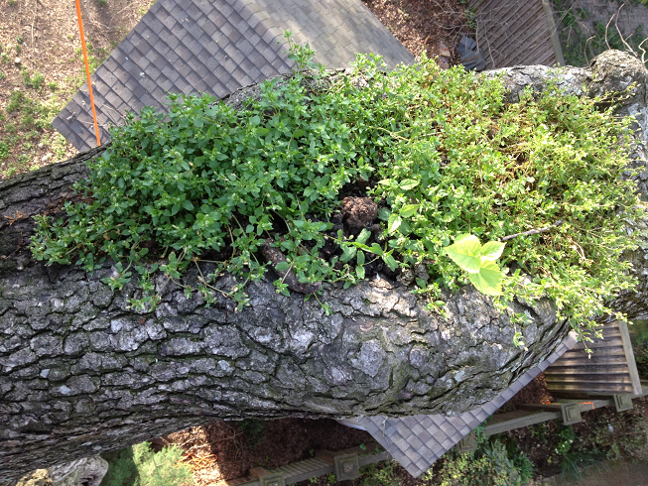
“I just found out how this weed grows so well here” he called down. “This canker is full of scat. Raccoons depend on vertical structures to climb when they feel threatened, and old oaks are preferred as sleeping, winter and litter dens Raccoons depend on vertical structures to climb when they feel threatened. Odor marks on prominent spots may establish home ranges and identify individuals. Waste left at shared latrines may provide additional information about feeding grounds. Raccoons have been observed to meet there later for collective eating, sleeping and playing.”
“So much for the reputation coons have for being super-clean.” she grimaced. “So is their use of the tree as a toilet bad for the tree?”
“Those waste products are high in nitrogen, and excess nitrogen is used by decay organisms, so I’d have to say yes.” I concluded. “Their waste is speeding the formation of hollows, and, coincidentally or not, habitat. Maybe that’s another method to their madness, and part of their plan. If the cankers are rinsed out, and exclusion devices installed, the areas might rot less, and grow more callus, and.”
“If that’s an alternative to removing end weight or cabling, let’s try it.” she said.
“Stay right there, Codit—I’ll be tying on a trowel and the garden hose. You’ll be doing a brand new arboricultural task today” I smiled. Codit wrinkled his nose as he pulled the tail of his climbing line so it hung directly below him.
“I see some chicken wire over there by your shed—may we use some?” I saw her nod approval as I tied a bag of tacks and the trowel and the hose to the wire, and the wire to the rope. Codit pulled it all up, looking none too happy about the upcoming task.
“How do we know this will do any good?” Codit complained. “ Maybe we should just let nature do its own thing.”
“Well, nature makes branches and trees fall down, among other things, so nature doesn’t always know best for urban trees.” I replied. “You’ll see it do good by assessing the depth of the canker, inserting the tacks at the edges of the callus growth, and taking a picture. Then we can compare the extent of this defect at later monitoring visits, and revise our treatments accordingly. This is known as the Appropriate Response Process.”
“I’ve heard pf that process before” Codit said. “Wasn’t it designed for Plant Health Care, not Tree Risk Assessment?”
“PHC, TRA, it’s all arboriculture. Health and safety are twin objectives—we’re managing for both—right?” Rosalita nodded vigorously. “This tree was standing when our grandparents were born. Dr. Treevorkian took an approach that is all too common—judging the tree in an artificially compressed time frame, instead of looking at it in tree time.”
“How did you know the other arborist’s name?” she asked. “I thought I deleted the identifying information before I sent it.”
“You did, but the quick defect-hazard-removal conclusion gave it away. Treevorkian isn’t familiar with ANSI A300 Part 9: At the 2006 ISA conference, Dr. Dan Marion delivered an excellent presentation on diagnosis and assessment, and demonstrated this work in the field to sold-out crowds. When he identifies a potential pathogen on or in a tree, Marion takes a four-dimensional approach, looking at length, height, width and time. This is similar to Francis Schwarze’s experimental studies of “trials of strength” between pathogen and host tissue conducted in blocks of wood. Marion recommends that arborists work on living trees, incorporating arboricultural treatments and observing the results over time. On surface infections, Marion measures the total circumference, divided by the width of the diseased area, to derive a “host/pathogen ratio”. In cavities, depth is measured by probing inside. Re-measuring at these same points indicates whether the treatments, such as root invigoration, fertilisation, pruning, mulching, pest management and irrigation, are working.
If good wood is growing faster than the defect, the host is gaining. No change in ratio indicates equilibrium, which tree and fungus are merely coexisting. Comparing camera images can save time and increase accuracy. Treatments take time to work, and sometimes the best they can do is prevent conditions from worsening. This is not a bad thing, but compartmentalisation of decay is generally the arborist’s goal for urban trees. The growth of wound wood or reaction wood around infections or other defects is an especially positive sign the tree is making an appropriate response. As any arborist whose hand has been nicked while pruning can testify, scar tissue is tougher than normal tissue! A negative trend over time may indicate a need for reduction pruning, support or removal. Marion’s systematic work with risk mirrors the Appropriate Response Process to plant health,

